Covid 19 Safety policy
Document Control
Policy title | Covid19 Safety Policy – The sk:n Group
Index reference number  (e.g. MST001/OPS 001) | MST 1001
Type of Document | Guidance
Version number | 2.1
Date Edited / Ratified | 11th November 2020
Issue Date | 2nd June 2020
Implementation Date | 16th June 2020
Review Date | Monthly Reviews until January 2021
Author(s) | Lisa Mason-Poyner, Claire Clarke, Isobel Bates
Policy Owner | Medical Standards Committee
Related Policies and Procedural Documents | Environmental Cleaning Policy  Clinic Risk Assessment  N:\Common Clinic Forms\Covid 19 Safety
Regulatory body standard | Care Quality Commission, Health Inspectorate Wales, Health Improvement Scotland
Areas affected by policy | All Clinics

Table of Contents
1.0 Introduction 3
2.0 Document Purpose 4
2.1 COVID-19 4
3.0 Standard precautions 4
3.1 Hand hygiene 4
3.2 Respiratory and cough hygiene – ‘Catch it, bin it, kill it’ 5
4.0 Triage 5
4.1 Temperature screening 7
4.2 Testing 7
5.0 Reception Area 7
6.0 Staff 7
6.1 People that are not involved in direct client care. 7
6.2 Staff working directly with clients 8
7.0 Personal Protective Equipment 8
7.1 When to use a surgical face mask or respirator mask 9
7.2 Respiratory protective equipment (RPE) – FFP 3 and FFP2 or N95 Masks 9
7.3 Fit Checking 9
Glove Policy and Procedure 10
7.4 Treatment Types 10
7.5 Training 12
7.6 Procurement, supply and risk assessment 13
Treatment specific Risk assessment and access to appropriate Personal Protective Equipment. 13
7.7 Sessional use of PPE 13
7.8 Donning and Doffing 14
7.9 Disposal of PPE 14
8.0 Cleaning and Waste Management 14
8.1 Equipment 15
8.2 Cleaning in common zones: 15
8.3 Cleaning in treatment rooms: 15
8.4 Cleaning solutions 16
9.0 Audit and Evaluation 16
10.0 Consent 17
11.0 Education 17
12.0 Skin Preparation 17
13.0 Time management 17
14.0 Covid 19 Positive or Suspected Covid 19 Positive Cases 17
15.0 NHS Track and Trace App and Contact Tracing 18
Here is a simple guide showing you how to turn off the contact tracing: 18
Appendix 1. PPE Guidance 20
Appendix 2. Covid 19 Risk Consent 22
Appendix 3. Mask types and uses 23

1.0 Introduction

This policy has been influenced by the outcome of a co-ordinated effort undertaken by the Joint Council of Cosmetic Practitioners (JCCP), working in conjunction with sk:n, to ensure, as far as is reasonably possible, that a safe and orderly resumption of practice is facilitated for our practitioners following Covid-19 lockdown. It presents a robust and evidenced series of procedures for use by practitioners and clinic staff.
The guidance should be used by practitioners to ensure that they comply with client safety and public protection standards required by both UK statutory professional and voluntary registers. It is hoped that the guidance will inspire confidence amongst members of the public who wish to resume their treatments.
The following points are important in placing an understanding of this guidance in context.
There are many unknowns relating to this coronavirus pandemic. This guidance is therefore subject to change as more information becomes available.
Risk remains. There is no policy or process which can entirely remove the risk of catching or transmitting the virus.
It is a guidance. It is therefore in addition to statutory obligations for Health and Safety, including COSHH, and should be seen as a basis for making sound clinical judgements.
Finally, this guidance should not be seen as a temporary requirement which can be discarded upon a return to the ‘norm’. The industry forms an important part of society which, through this pandemic, will ‘reset’ and revert to a ‘new normal’. This new ‘norm’ may be characterised by a vigilant, competent, educated and responsible workforce and by better informed members of the public, allowing us to meet future challenges together in a responsive and proactive way.

2.0 Document Purpose
The purpose of this document is to outline infection prevention and control advice for clinics performing non-surgical treatments.
This infection prevention and control advice is considered good practice and has been approved by the response to the COVID-19 pandemic. It is based on the best evidence available from appropriate bodies, including P.H.E.
Emerging evidence base on COVID-19 is rapidly evolving, therefore further updates will be made to this guidance as new detail or evidence emerges.

2.1 COVID-19
The transmission of COVID-19 is thought to occur mainly through respiratory droplets generated by coughing and sneezing, and through contact with contaminated surfaces. The predominant modes of transmission are assumed to be droplet and contact. This is consistent with a recent review of modes of transmission of COVID-19 by the World Health Organization (WHO).
https://assets.publishing.service.gov.uk/government/uploads/system/uploads/attachment_data/file /881489/COVID-19_Infection_prevention_and_control_guidance_complete.pdf

As there is currently no vaccine to prevent COVID-19, the best way to prevent infection is to avoid being exposed to the virus. Public Health England (PHE) recommends that the following general cold and flu precautions are taken to help prevent people from catching and spreading COVID-19:
- Cover your mouth and nose with a tissue or your sleeve (not your hands) when you cough or sneeze. Remember Catch it, Bin it, Kill it
- Put used tissues in the bin straight away
- Wash your hands with soap and water often – use hand sanitiser gel if soap and water are not available.
- Try to avoid close contact with people who are unwell
- Clean and disinfect frequently touched objects and surfaces
- Do not touch your eyes, nose or mouth if your hands are not clean.
- If you are worried about symptoms refer to Covid 19 protocol for employees. Or contact HR.

3.0 Standard precautions

3.1 Hand hygiene
All staff must complete the Handwashing training module before returning to work and every 6 months The Clinic Manager is responsible for ensuring their clinic team have completed the module.
Hand hygiene is essential to reduce the transmission of infection. All staff and clients should decontaminate their hands with alcohol-based hand rub when entering and leaving areas where client care is being delivered.
Hand hygiene must be performed immediately before every episode of direct client care and after any activity or contact that potentially results in hands becoming contaminated, including the removal of personal protective equipment (PPE), equipment decontamination and waste handling. Refer to 5 moments for hand hygiene.
https://www.who.int/infection-prevention/campaigns/clean-hands/5moments/en/

Before performing hand hygiene:
Expose forearms (bare below the elbows).
Remove all hand and wrist jewellery (a single, plain metal finger ring is permitted but should be removed (or moved up) during hand hygiene).
- ensure fingernails are clean, short and that artificial nails or nail products are not worn
- cover all cuts or abrasions with a waterproof dressing.
- if wearing an apron rather than a gown (bare below the elbows), and it is known or possible that forearms have been exposed to respiratory secretions (for example cough droplets) or other body fluids, hand washing should be extended to include both forearms. Wash the forearms first and then wash the hands.
- alcohol-based hand-rub dispensers in the laser room
Placement of these flammable products must be in compliance with national regulations. Alcohol-based hand hygiene product dispensers should:
- be at least 1 m 20 cm (4 ft) apart.
- hold a maximum of 1.2 L in rooms, corridors and areas open to corridors.
- not be placed above an ignition source or within 2.5 cm of the ignition source.
Source: Guideline for hand hygiene. In: Guidelines for Perioperative Practice. Denver, CO: AORN, Inc.
It is important to keep hands well moisturised. Keep hand cream available for all staff and clients to use.

3.2 Respiratory and cough hygiene – ‘Catch it, bin it, kill it’
Clients and staff should be encouraged to minimise potential COVID-19 transmission through good respiratory hygiene measures which are:
- disposable, single-use tissues should be used to cover the nose and mouth when sneezing, coughing or wiping and blowing the nose – used tissues should be disposed of promptly in the nearest waste bin.
- tissues, waste bins (lined and foot operated) and hand hygiene facilities should be available for clients and staff
- hands should be cleaned (using soap and water if possible, otherwise using ABHR) after coughing, sneezing, using tissues or after any contact with respiratory secretions and contaminated objects.
- encourage clients to keep hands away from the eyes, mouth and nose.

4.0 Triage
The following questions should be posed to every client before booking an appointment and as close to the appointment as possible.
Client Pre-Booking Questions
Have you or anyone in your household or support bubble been tested for coronavirus? If Yes what was the result?  If tested positive in the last 2 weeks, rearrange appointment post 2 weeks of result. | Yes / No
Have you or anyone in your household have a high temperature – this means you feel hot to touch on your chest or back in the past two weeks?  If client has thermometer temperature of 37.8c may represent fever. | Yes / No
Have you or anyone in your household had a new, continuous cough – this means coughing a lot for more than an hour, or 3 or more coughing episodes in 24 hours (if you usually have a cough, it may be worse than usual)cough or other respiratory problems in the past two weeks? | Yes / No
Have you or anyone in your household had a loss of or change in your normal sense of taste and smell?  If Yes and it was in the past 14 days - self isolate. | Yes / No
Have you had any other symptoms suggestive of a viral infection within the last two weeks, such as muscle pain, lethargy, diarrhoea or vomiting? | Yes / No
Do you suffer from any of the following?  - have a lung condition that's not severe (such as asthma, COPD, emphysema or bronchitis)  - have heart disease (such as heart failure)  - have diabetes  - have chronic kidney disease  - have liver disease (such as hepatitis)  - have a condition affecting the brain or nerves (such as Parkinson's disease, motor neurone disease, multiple sclerosis or cerebral palsy)  - have a condition that means they have a high risk of getting infections  - are taking medicine that can affect the immune system (such as low doses of steroids)  - a BMI of 40 or above  The NHS classify these conditions as moderate risk (clinically vulnerable). You may be at higher risk and you are more likely to get seriously ill from coronavirus. | Yes / No
Have you travelled outside the UK in the past 14 days to a country that is not on the current exempt list?  https://www.gov.uk/guidance/coronavirus-covid-19-travel-corridors | Yes / No
TEMPERATURE CHECK READING

In the event that the client successfully triages, they must be given the following instructions either via phone or email.
Please attend your appointment unaccompanied.
Upon arrival, you will be asked to wash your hands,wear a face covering or mask and use the NHS Covid19 track and trace app Refer to Medical Bulletin released 22.09.2020 for further details.
We ask that you do not bring personal possessions to the clinic. Please limit the wearing of jewellery. Wedding rings may be worn provided hands are kept clear from the face. Minimal make-up should be worn (so the practitioner doesn’t have to spend time removing make up and reduce contact time). If make-up is worn to the clinic, you will be asked to remove it.
When the treatment is complete, you will be invited to wash your hands.
Please maintain the requisite distance of 2 meters from other people in the clinic as far as is possible.
We urge clients to pay by card only or contactless, reducing contact wherever possible and cleaning card machines after use where necessary. If for any reason payment by cash is unavoidable, additional precautions, including hand washing, must be taken.
Appointments should be by prior arrangement. Signage should be placed on the front door to inform clients that the clinic runs on an appointment only system.
Attend your appointment 5 minutes early. In some instances we may ask that you wait in your car until your practitioner is ready to see you.
Clients will be asked to attend with no make-up for facial assessment and treatment and hair removed for laser procedures where appropriate.

4.1 Temperature screening
All clients will have their temperature checked as part of the triage to preclude clients having treatment or consultations with an elevated temperature (pyrexia).

4.2 Testing
Sk:n currently make no definitive recommendations for routine antigen/antibody testing for CoVSARS-2. Please refer to the Covid 19 protocol for employees. As government guidance and testing availability develops, we will review this policy for future versions of this guidance.

5.0 Reception Area
A spot marker should be placed 2 metres in front of the reception desk to encourage people to stand at a safe distance away from the desk.
A perspex screen is to be placed on the reception desk if the local risk assessment indicates this.
To maximise social distancing, limit the number of clients in the reception area at any time.
Provision must be made to ensure 2m distancing at all times by spreading chairs apart and considering use of other rooms as additional waiting areas.
If there is insufficient space in the waiting area to allow for social distancing, clients should be asked to wait outside and will be called when the practitioner is ready to start treatment.
No children or additional people are permitted to accompany the client to the treatment session.
The time spent in the clinic by the client should be minimised as much as possible.
Windows should be opened wherever possible.
Hand sanitiser must be available in the waiting area, but not on the reception counter, as this will encourage breaking the 2 metre distancing rule.
Reception areas should be maintained as paper free wherever possible.
If clinic premises permit, have one door for entering the building and one for exiting if possible and demonstrate a one way flow using pointers on the floor. This will be indicated by the Risk Assessment.
Clients should be given the Covid19 Risk Consent Form to read and sign. Allow them time to read in full.

6.0 Staff
Staff are classified into two types for the purposes of this document:
Employees who work mainly in the reception area and not involved with direct client care and secondly, employees that are in direct contact with clients.

6.1 People that are not involved in direct client care.
Work attire must not be worn on the journey in to or from work.
Frequent cleaning of keyboards, phones and other frequently used items using cleaning solutions designated in section 8.4 will be required. Ensure enough cleaning product is available.
As teamwork and environmental awareness is highly important, the receptionist should be designated as the principal rule enforcer of the safety ‘new regime’.
As each client/client leaves the clinic, reception staff must leave the reception area, and clean the area with an appropriate product (section 8.4) and then return immediately to the reception area, and clean their hands.
Hand washing definition: hand hygiene measures should be used with soap and water. This is the most important measure to reduce the risks of transmission and must be carried out frequently (before putting on gloves, after removing gloves, and after each contact with the client whether or not gloves have been used). Normal liquid soap will be used for hygienic washing. Hands must be dried with disposable towels. Another option is to use hand sanitiser, but it is not as a substitute for frequent hand washing.

6.2 Staff working directly with clients
The wearing of jewellery, nail polish and other non-essential accessories should be minimised. Artificial nails should not be worn in the clinic environment. Any nail other than a natural nail is considered artificial. Artificial nails are defined as any substance or device applied or added to the natural nails to augment or enhance the nail, including bonding, extensions, tips, wraps, gel and acrylic overlays, and tapes. Artificial nails have been associated with hand contamination and epidemiologically implicated in outbreaks caused by gram-negative bacteria and yeasts.
Source: Guideline for hand hygiene. In: Guidelines for Perioperative Practice. Denver, CO:AORN, Inc.

Uniforms must not be worn on the journey in to or from work.
Employees should carry their uniform and shoes in a disposable bag. Allowing for the two metre distancing rule, uniform should be changed into on site. Handbags and personal possessions such as phone/ipads etc. should be safely stored in a locker or other safe place.
Don the PPE appropriate to the procedure to be performed. Avoid returning to the changing place except to change out of your uniform at the end of the day.
At the end of the shift, wash hands thoroughly, place the uniform and shoes into the bag. On a daily basis, uniforms should be washed at a temperature exceeding 60 degrees.

7.0 Personal Protective Equipment
Careful client pathways and excellent infection control behaviours have been shown to reduce transmission in both directions more significantly than use of PPE.
Infectious viral transmission is by droplets >10 μm* and/or aerosol. Inhalable infectious particles (aerosol) have a particle size of less than ≤5 μm*. However, face masks are considered 'the last line of defence’ where other practices such as frequent hand washing / sanitising and social distancing are much more effective in preventing infectious droplet or aerosol transmission.
Certain procedures convey higher risk of transmission. For example, aerosol generating procedures (AGPs) present risk of aerosolised transmission.
This guidance therefore seeks to set out clear and actionable recommendations on the use of PPE, as part of safe systems of working. Incidence of COVID19 varies across the UK and risk is not uniform. Guidance reflects recommendations from PHE on PPE for primary, outpatient, community and social care by setting, NHS and independent sector and consensus guidelines for aesthetic clinics. And the government guidance on close contact services.
- FFP’ is a European statement of efficiency according to the EN149 standard. In obtaining facemasks, practitioners may be presented with a range of different international ‘standards’ and it will be necessary that they become familiar with these. As a working guide, ‘FFP2’ (95% efficiency at filtering to 0.3 microns) is approximately equivalent to the Chinese ‘KN95’ and the American ‘N95’ standards.
- The UK recommends the use of FFP3 respirators when caring for patients in areas where high risk aerosol generating procedures (AGPs) are being performed. When FFP3 respirators are not available, then FFP2 respirators may be used.
https://www.hse.gov.uk/news/face-mask-equivalence-aprons-gowns-eye-protection-coronavirus.htm
PPE requirements by treatment type are outlined in Appendix.2
Staff not directly involved in client care, i.e. in reception will wear face coverings or mask. Aprons and gloves should be available to them. Handwashing facilities or hand sanitiser (60% alcohol) should be available to all staff not working directly with clients.

7.1 When to use a surgical face mask or respirator mask
Barrier precautions such as masks and respirators are regarded as the last line of defence against viral transmission. Nevertheless, Public Health England (PHE) recommends the use of an FFP3 respirator when caring for clients in areas where high risk aerosol generating procedures (AGPs) are being performed. A surgical face mask may not be adequate protection in these circumstances.
The World Health Organisation (WHO) recommends FFP2 and N95 respirators for AGPs and these are widely used in other countries. PHE has found that there is no material difference between the N95 respirator and the FFP2 disposable respirator. They provide comparable protection against coronavirus as long as the wearer has passed a face fit test.

7.2 Respiratory protective equipment (RPE) – FFP 3 and FFP2 or N95 Masks
Tight-fitting respirators (such as disposable FFP3 masks and reusable half masks) rely on having a good seal with the wearer’s face. A face fit test should be carried out to ensure the respiratory protective equipment (RPE) can protect the wearer.
RPE with exhalation valves protect the wearer. If a disposable FFP 2, N95 or FFP 3 mask is worn with an exhalation valve during a close contact treatment a Face Visor should be worn over the top of the FFP mask to protect the client. If a Face Visor cannot be worn then a Surgical Mask should be worn over the FFP mask. This will also help extend the life of the FFP. Face Visors worn direct breath away from the client.

7.3 Fit Checking
This is required to ensure the fit of the mask is checked every time it is used. Here's what you need to know.
- Fit checking is not a regulatory requirement but should be regarded as good practice by the wearer.
- The user must be trained on how to carry out a fit check.
- The HSE has guidance on fit checks, including an instructional video (see below).
To ensure you put on tight-fitting RPE correctly, use a mirror or ask a colleague. Fit-testers should follow government advice on social distancing, as they can make observations from this distance and deliver any instructions verbally.
The user should then carry out a pre-use seal check or fit check. The following poster and video give guidance on how to put on disposable respirators and how to do a pre-use seal check or fit check. Posters of these should be displayed clearly in the clinic for staff.
https://www.hse.gov.uk/pubns/disposable-respirator.pdf
https://www.youtube.com/watch?time_continue=4&v=iVVlTBcN5eA&feature=emb_logo
https://www.rcn.org.uk/magazines/bulletin/2020/june/fit-test-vs-fit-check-covid-19
Facial hair may compromise the seal. Please see page 62 of the following guidance document:
https://assets.publishing.service.gov.uk/government/uploads/system/uploads/attachment_data/file/ 881489/COVID-19_Infection_prevention_and_control_guidance_complete.pdf

Disposable plastic aprons should be worn to protect medical gowns, staff uniform or other clothes from contamination when providing direct client care and during cleaning / decontamination procedures.
Disposable aprons must be changed between clients and immediately after completion of cleaning / decontamination procedures.

Glove Policy and Procedure
As the hands of practitioners are one of the most likely means of transmitting infection to others, disposable examination gloves must be worn when providing direct client care and during cleaning / decontamination procedures. The purpose of wearing gloves is to:
- protect the hands from becoming contaminated with viruses and bacteria;
- prevent the transfer of viruses and bacteria already present on the skin of the hands and to minimise cross infection during cleaning / decontamination procedures.
- Gloves of appropriate quality should be used i.e. domestic type rubber for cleaning purposes and well fitting, single-use, nitrile or vinyl sterile examination or surgical gloves for client procedures.
- Gloves must be changed at the end of each procedure
- Gloves must be made easily available for staff use
- Gloves must be changed between performing each procedure
- Hands should always be washed after wearing gloves

7.4 Treatment Types
Treatment types have been classified as Low, Medium or High risk, dependent on aerosol generation.

Risk categorisation of various aesthetic procedures based on consensus guidelines | Treatment Type
High | Laser Hair Removal Face - non contact cooling
High | Laser Hair Removal Body - non contact cooling
Moderate | Laser Hair Removal Face - contact cooling
Low | Laser Hair Removal Body - contact cooling
High | Laser Tattoo Removal Body
High | Laser Thread Veins Face - non contact cooling
Low | Laser Thread Veins Face - contact cooling or no cooling
Moderate | IPL ( Isolaz)
Moderate | Laser Resurfacing (non-ablative)
High | Laser Resurfacing (ablative Co2, Ery:YAG)
Low | Skin resurfacers and Chemical Peels
Moderate | Microneedling Needling System
High | Microdermabrasion
Low | Injectables upper face (client can wear mask)
Moderate | Injectables (botulinum toxin, dermal fillers) for middle and lower third facea
Moderate | Thread lifts
Low | Facials
Low | Hydrafacial
Low | Body Treatments (non-laser)
Low | Consultations and Reviews (where 2 metre distance guidance met)
 | Wound Care/Suture Removal
Low | Sclerotherapy
Dermatology
High | Dermatology led procedures removing tissue, i.e. lesions/ moles/ warts CAUTERY - Above Clavicle
High | Dermatology led procedures removing tissue, i.e. lesions/ moles/ warts CAUTERY - Below Clavicle
Moderate | Dermatology led procedures removing tissue, i.e. lesions/ moles/ warts NO CAUTERY Above Clavicle
Low | Dermatology led procedures removing tissue, i.e. lesions/ moles/ warts NO CAUTERY Below Clavicle
 | Cryotherapy

Source: https://onlinelibrary.wiley.com/doi/10.1111/dth.13597
Plume generating procedures: laser
Factors to be considered:
- The extent of plume
- The use of mechanical ventilation for extraction.
- Treatment length
- Any additional risk factor identified

Extended time periods will be allowed for room ventilation prior to use by another client.
Special precautions should be taken when treating facial areas, as the face is a much higher risk field. Treatments with plume producing laser, intense pulsed light (IPL) and energy-based devices (which include gasses such as are released during laser/IPL hair reduction treatment) and cooling devices that blow cold air or cryogen, should be used with smoke evacuation if ventilation in the room is of poor quality. This will be demonstrated by the clinic Risk Assessment.
Any procedures performed to head and neck should involve prolonged hand and face washing by the client (>20 secs) by the client with skin cleanser and water. Clients should be encouraged to attend the clinic with no or minimal make-up to reduce contact time.
Treatment Time: Treatments should be of short-term duration, preferably, not exceeding 1 hour. Where a client requires a longer period of time for a laser procedure they should be encouraged to return at another time or a 15 minute break should be taken.
Clinics should, where possible, should consider alternating rooms and arranging higher risk treatments at the end of the day.
Ablative Laser Procedures
FFP3 mask, or FFP2 where FFP 3 are not available should be used where there is a risk of the laser operator inhaling blood aerosol or other airborne particulates such as are produced during tattoo pigment removal, skin ablation.
We therefore recommend that all procedures which create a plume should be undertaken in line with recommendations for aerosol generating procedures, including relevant use of PPE.

Minor Surgical Procedures
During electrosurgery, bacteria and viruses, along with a host of chemicals and toxins are released into the air through smoke plume. This plume contains particles of different natures and varying sizes.
If a surgical smoke evacuator is not used, these particles are inhaled by anyone nearby and will carry any bacterial and viral pathogens directly into the respiratory system.
The Control of Substances Hazardous to Health Regulations (COSHH – 2002) require that exposure to substances hazardous to health, such as surgical smoke plume, are adequately controlled to prevent ill health. The HSE (Health and Safety Executive) and NICE (National Institute for Health and Care Excellence) advise that in order to lower the risks caused by surgical smoke plume a smoke evacuation system, such as the Acu-Evac, should be used. The NATN (National Association of Theatre Nurses), state that dedicated smoke evacuators must be used and the filters checked and changed regularly. They also suggest high filtration face masks should be worn to minimise the inhalation of carbonaceous particles. There are a huge number of clinical papers to support the value of investing in a smoke evacuation unit, outlining the short term and long term implications which have been linked directly to smoke plume inhalation.

7.5 Training
Staff should be trained on ‘donning and doffing’ PPE. Videos are available showing how to ‘don and doff’ PPE for AGPs and how to ‘don and doff’ PPE for non-AGPs. https://www.gov.uk/government/publications/covid-19-personal-protective-equipment-use-for-aerosolgenerating-procedures
https://www.gov.uk/government/publications/covid-19-personal-protective-equipment-use-for-nonaerosol-generating-procedures
Staff should know what PPE they should wear for each setting and context staff should have access to the PPE that protects them for the appropriate setting and context.
Gloves and aprons are subject to single use, with disposal after each client.
Fluid repellent surgical mask and eye protection can be used for a session of work rather than a single client contact.

Hand hygiene should be practised and extended to exposed forearms, after removing any element of PPE.

7.6 Procurement, supply and risk assessment
EN 149 is the European standard required to ensure respirator face masks meet conformity requirements. Due to supply problems of PPE, it is possible that practitioners are unable to obtain the required type of mask, or that the relevant mask is not specified with the required conformity. The government have made urgent arrangements to obtain PPE which maintains conformity but obviates the need for EN assessment and CE labelling.
Therefore, when ordering face masks, they must only be ordered if on the organisations approved list of PPE and the following should be taken into consideration.It is imperative that PPE, including face masks, is purchased from a reputable supplier. It is the responsibility of the distributor to ascertain that appropriate conformity is in place.
‘FFP’ is a European statement of efficiency according to the EN149 standard. In obtaining facemasks, practitioners may be presented with a range of different international ‘standards’ and it will be necessary that they become familiar with these. As a working guide, ‘FFP2’ (95% efficiency at filtering to 0.3 microns) is approximately equivalent to the Chinese ‘KN95’ and the American ‘N95’ standards.
https://www.hse.gov.uk/news/assets/docs/face-mask-equivalence-aprons-gown-eye-protection.pdf

We recommend that practitioners perform a visual inspection of face masks/visors prior to use, to include:
General integrity –
Straps– ensure they are present and intact
Face seal– visual check to ensure the seal is undamaged
Nose clip (if applicable) – must be present and intact
Filtering material – ensure there are no visible defects
Finish of parts – inspect to ensure there are no sharp or jagged edges
Valve (if applicable) – present and intact

Treatment specific Risk assessment and access to appropriate Personal Protective Equipment.

Risk assessment
Clients should be viewed as potentially Covid 19 positive. Of equal importance is the need to regard perioral treatments, lip fillers and intraoral treatments, such as dental blocks, as potentially aerosol generating procedures (AGP’s), requiring the use of FFP 2face masks.

It must be remembered that face mask use is only one pillar supporting the defence against Covid 19, and that gowns and gloves, eye protection, distancing and modified behavioural responses are equally important.
Please refer to the local clinic Risk Assessment.

7.7 Sessional use of PPE
Aprons and gloves are subject to single use as per Standard Infection Control Precautions (SICPs), with disposal and hand hygiene after each client contact. Respirators, fluid-resistant (Type IIR) surgical masks (FRSM), eye protection and disposable fluid repellent coveralls or long-sleeved disposable fluid repellent gowns can be subject to single sessional use in circumstances outlined in Appendix 1 and section 5.7.
A single session refers to a period of time where a practitioner is undertaking duties in a specific clinical care setting or exposure environment. Once the PPE has been removed it should be disposed of safely.

The duration of a single session will vary depending on the clinical activity being undertaken.

While generally considered good practice, there is no evidence to show that discarding disposable respirators, facemasks or eye protection in between each client reduces the risk of infection transmission to the practitioner or client. Indeed, frequent hand washing of this equipment to discard of replace it could theoretically increase risk of exposure in high demand environments, for example by leading to increasing face touching during removal. The rationale for recommending sessional use in certain circumstances is therefore to reduce risk of inadvertent indirect transmission as well as to facilitate efficient clinical care.

PPE should not be subject to continued use if damaged, soiled, compromised, and uncomfortable and a session should be ended. While the duration of a session is not specified here, the duration of use of PPE items should not exceed manufacturer instructions. Appropriateness of single versus sessional use is dependent on the nature of the task or activity being undertaken and the local context.
Eye protection and lenses or face visor, where reusable, must be disinfected between clients; to do this use solutions in section 8.4 or consider proprietary brands: Use 2 Clinell® wipes or first with detergent and warm water and then solution of Sodium chlorine 1000ppm i.e. Actichlor® or Presept®.

7.8 Donning and Doffing
Please refer to the Public Health Guidance - Guide to ‘donning and doffing’ standard Personal Protective Equipment (PPE). All staff should complete the ‘donning and doffing’ training before commencing work in the clinic.
https://assets.publishing.service.gov.uk/government/uploads/system/uploads/attachment_data/file/ 877658/Quick_guide_to_donning_doffing_standard_PPE_health_and_social_care_poster__.pdf

7.9 Disposal of PPE
All used PPE should be deposited in the appropriate waste bin with a hard cover and pedal opening. Safe and responsible arrangements should be made for the emptying and disposal of all used PPE materials.

8.0 Cleaning and Waste Management
Staff should read the Environmental Cleaning policy and information on the proper cleaning methods required.
A thorough cleaning and disinfection of surfaces and areas of contact with the client should be carried out after every procedure.
Inform the client of the disinfection of the treatment room between clients and to explain the cleaning procedure to the client for their own piece of mind.
Cleaning offices and public spaces where there are suspected or confirmed cases of COVID-19 Coronavirus symptoms are similar to a flu-like illness and include cough, fever, or shortness of breath. Refer to Environmental Cleaning policy.
Once symptomatic, all surfaces that the person has come into contact with must be cleaned including:
all surfaces and objects which are visibly contaminated with body fluids
all potentially contaminated high-contact areas such as toilets, door handles, telephones Public areas where a symptomatic individual has passed through and spent minimal time in (such as corridors) but which are not visibly contaminated with body fluids do not need to be specially cleaned and disinfected.
If a person becomes ill in a shared space, these should be cleaned using disposable cloths and household detergents, according to current recommended workplace legislation and practice.
Rubbish disposal, including tissues.
All waste that has been in contact with a suspected affected case, including used tissues, and masks if used, should be put in a plastic rubbish bag and tied when full. The plastic bag should then be placed in a second bin bag and tied. It should be put in a safe place and marked for storage until the result is available. If the individual tests negative, this can be put in the normal waste. Should the individual test positive, the clinic will be instructed what to do with the waste.

8.1 Equipment
Equipment should be single-use items if possible.
Reusable, non-invasive equipment must be decontaminated:
- between each client and after client use
- after blood and body fluid contamination
- at regular intervals as part of equipment cleaning
Instrument\Handpiece Cleaning
Cleaning and disinfection of the laser handpiece, along with regular washing and disinfection of safety eyewear and cooling gel packs, should be conducted under the protocols recommended by the manufacturer. Other supplies routinely used in the clinic are single-use items and should be disposed of after each client.

8.2 Cleaning in common zones:
At the end of the working day, all common areas should be subjected to a thorough cleaning and disinfection regime.

All door and window knobs, possible handrails, tables, armrests for chairs and armchairs, switches, telephones, should be cleaned and disinfected with sodium hypochlorite solution, whenever the material allows it.

8.3 Cleaning in treatment rooms:
All surfaces including work surfaces and treatment couch must be wiped down with a cleaning solution at the end of every treatment.
The room should have a daily and weekly environmental cleaning schedule. Depending on the surface material, floors should be vacuumed daily (not in minor ops room) or mopped clean utilising a general-purpose disinfectant. All horizontal surfaces should be cleaned with a disinfectant solution dilution of 1,000 parts per million available chlorine (ppm available chlorine (av.cl.) or equivalent. Note: Glutaraldehyde and phenol are not recommended as disinfectants because of the health risks involved in their usage.
High-touch points such as door handles, knobs, handrails, switches, chair armrests, telephones, keyboards, desks, examination couches, table tops, wash handbasins and toilets should be wiped regularly with suitable alcohol wipes (>60%). Clean and disinfect couches and change disposable couch roll between clients. Empty waste receptacles daily.
Toilet facilities with hot and cold running water must be cleaned and disinfected at least twice daily and after client use. Liquid soap and disposable paper towels will be provided. Clean from the cleanest areas to the dirtiest and don’t pass twice over the same area.
Towels and washcloths used when washing the skin or used to maintain client privacy and dignity when treating intimate body areas must not be used. Disposable couch roll is a suitable alternative.

Room ventilation
Clearance of infectious particles is dependent on the mechanical/natural ventilation within the room. A single air change is estimated to remove 63% of airborne contaminants; after 5 air changes, less than 1% of airborne contamination is thought to remain.
We understand that most clinics and practitioners will not have access to determining the air change rate within their clinical environment. However, practitioners should understand the principle that it is reasonable to recommend an extended period at the end of each treatment session to allow for room ventilation and air exchange. Doors should be kept shut at this time but windows may be opened to aid the exchange rate.
Avoid the use of fans that re-circulate the air.
If using cold air machines during procedures, this should be used at sufficient levels to cool the skin without excessive circulation of air.

8.4 Cleaning solutions
The SARS-Cov-2 virus is contained within a lipid envelope and therefore is susceptible to inactivation with detergents.
Evidence recommends the use of alcohol solutions at 70% or sodium hypochlorite solutions at 0.1% for non-clinical environments. (Sodium hypochlorite 0.1% may be obtained by diluting household bleach, which is typically at concentrations of 5%. Therefore, a solution of 1:50 will provide 0.1%. However, you should confirm the initial concentration of the product as it may vary across brands. Chlorhexidine has been found to be less effective in inactivating the virus. For clinical environments, the use of chlorine releasing agents is indicated - Presept or Actichlor or Sanichlor tablets diluted are all appropriate options.

If alternative products are used, it is recommended that practitioners should refer to manufacturer advice on the suitability for use of the product as a lipid envelop virucide, to the EN 14476 standard.

The DEFRA website has a list of disinfectants that have qualified for use against a list of known pathogens. As an alternative, use generic sodium hypochlorite solution in a one to 100 dilution of chlorine Make sure any soil is removed from surfaces before applying this dilution and note that it can cause respiratory symptoms and persons using it should do so with caution and in well ventilated areas.
Sources: Department for Environment Food and Rural Affairs DEFRA website.

9.0 Audit and Evaluation
An evaluation should be performed at the end of every day with members of staff as a way of ensuring of continuous improvement in quality standards.
A self-assessment audit should be completed on a monthly basis to ensure the clinic is adhering to the stated policy, to confirm that the policy is effective and responsive to changing demands and new advice provided by government agencies. Practitioners should engage in a process of continuous quality improvement to enhance public protection and client safety standards.

10.0 Consent
All clients must complete the Covid 19 Risk Consent Form before proceeding with any procedure. This must be secured to the client’s clinical notes.
In addition to treatment specific consent the practitioner, must ensure that the client has a complete understanding of the potential impact that Covid19 might have upon the treatment. This will allow the practitioner and client to reach a mutual agreement in ‘weighing up’ risks and benefits in order to achieve and inform valid consent.
It is important that the client understands the rationale for the various measures taken, both by practitioner and client, to minimise risk. This relates to both peri and post procedural care and will further enable the client/client to take a broader and more informed approach to future decision making in relation to their health and wellbeing.
It is particularly important that members of the public understand that these measures cannot completely remove all risk in relation to Covid-19. As such members of the public must be provided with sufficient time to consider this fact prior to consenting and receiving treatment.

11.0 Education
These requirements imposed on the client will undoubtedly be unfamiliar to them and there is the possibility, in some instances, of resistance or lack of concordance
Sk:n will provide detailed guidance on websites and directing clients to this and provide individual instructions with each appointment made e.g. through email or telephone.
Client guidance will consider ‘what to expect’ when viewed from the client’s perspective. It should be written in layman’s terms and supported with rationale to aid understanding and acceptance. Only through education and understanding can compliance be fully achieved, thereby reducing treatment risk in the first instance and optimising wellbeing in the longer term.

12.0 Skin Preparation
No changes are required in the use of preparatory skin cleaning, assuming this is usually performed with solutions containing ethyl alcohol, or a hypochlorite solution such as Clinisept®. There is evidence that clorhexidine is less effective in the removal of SARS-Cov-2.

13.0 Time management
To ensure appropriate time is allowed for cleaning, ventilation and donning and doffing of PPE, appointment time will be increased, whilst reducing client contact time. This will limit unnecessary exposure time and reduce the risk of human error in a stressful environment. Where lengthy treatments are proposed, a risk assessment should be performed.
Staff may be required to be more flexible in their working times to meet these demands.

14.0 Covid 19 Positive or Suspected Covid 19 Positive Cases
Should you be in a situation where you believe that a suspected COVID-19 positive client has been in the clinical area you must:
- Immediately stop all activity.
- Ensure no other clients are admitted to the waiting room.
- Doors should be kept closed with windows open to improve airflow and ventilation.
- Use disposable cloths/papers/mop attachments and either a combined detergent disinfectant solution at a dilution of 1000 parts per mission (ppm) available chlorine (av.cl) or a neutral purpose detergent followed by disinfection (1000ppm av.cl)
- Dispose of all cleaning cloths/wipes as well as all waste associated with suspected positive patient into a waste bag. If clinical waste is collected at your premises ensure it is disposed of in the clinical waste; if this is not possible seal the bag tightly in another bag and store for 72 hours and dispose of in the standard waste, ensuring adequate PPE and hygiene before and after contact.
- Refer to Environmental Cleaning Policy.

15.0 NHS Track and Trace App and Contact Tracing

As per Government guidelines, all Clinics have been required to implement NHS Track and Trace QR codes and associated posters. Staff are reminded that they do not need to use these posters to log in to their place of work, and whilst the Business strongly encourages all Staff to download the NHS Track and Trace App, the contract tracing must be turned off whilst you are working within the clinic. (This does not apply if you are attending as a Client outside of your normal working pattern and are not in full medical grade PPE.) This is to ensure no false positive Covid exposure alerts are generated should a Client later test positive for Covid-19, and your mobile was within a certain radius of the Client; the App does not know you are in a clinical setting in full PPE, and you will receive a message requiring you to self-isolate. The contract tracing function can easily be switched off from the app and it is recommended that you allow the App to remind you to switch this function back on at a later point, so that you do not forget when you leave, following your shift.

Here is a simple guide showing you how to turn off the contact tracing:
Swipe to turn off – the app shows you if it is currently active and scanning.

OTHER RESOURCES
How to wash your hands available at: https://www.nhs.uk/live-well/healthybody/best-way-to-washyour-hands/
NHS WSWRD poster available at:
https://www.england.nhs.uk/south/wpcontent/uploads/sites/6/2017/09/hand-hygiene-poster.jpg
Corona Virus Wash Your Hands NHS video available at: https://youtu.be/GldAajY4UGM
COVID-19: infection prevention and control guidance available at: https://assets.publishing.service.gov.uk/government/uploads/system/uploads/attachment_data/file / 881489/COVID-19_Infection_prevention_and_control_guidance_complete.pdf
Local Resumption of Elective Surgery Guidance. American College of Surgeons. 17th April 2020.
Level 4 COVID-19 lockdown – AAMSSA Guideline for the Aesthetic Practitioner. 28th April 2020.
Kampf G, Todt D, Pfaender S, Steinmann E. Persistence of coronaviruses on inanimate surfaces and their inactivation with biocidal agents. J Hosp Infect. 2020; 104(3):246-251.
Australasian College of Cosmetic Medicine (ACAM) Autumn Newsletter April 2020. Available at:
https://mailchi.mp/31959816f0d9/acam-spring-newsletter-special-conferenceedition3036370?e=7288a30982

Appendix 1. PPE Guidance
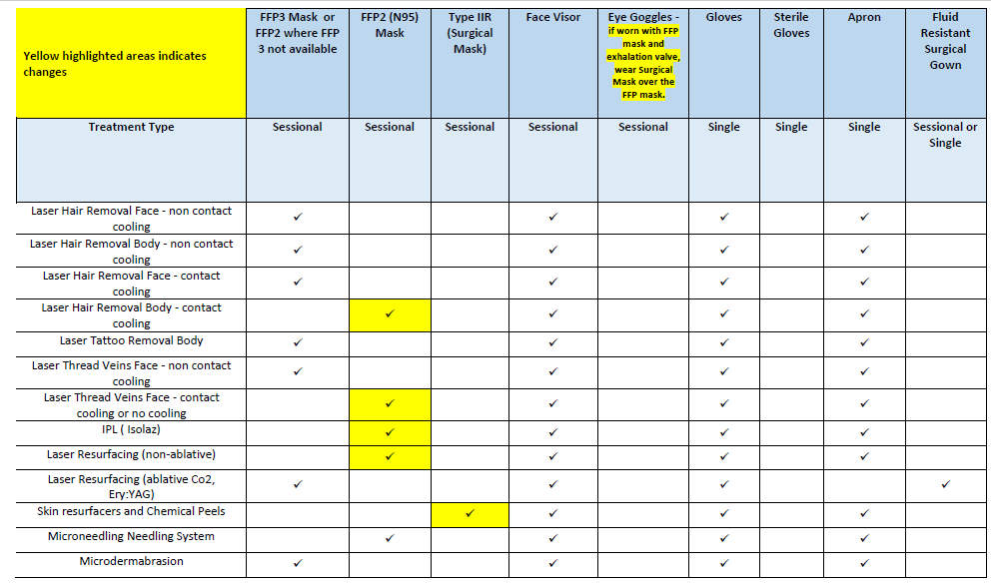
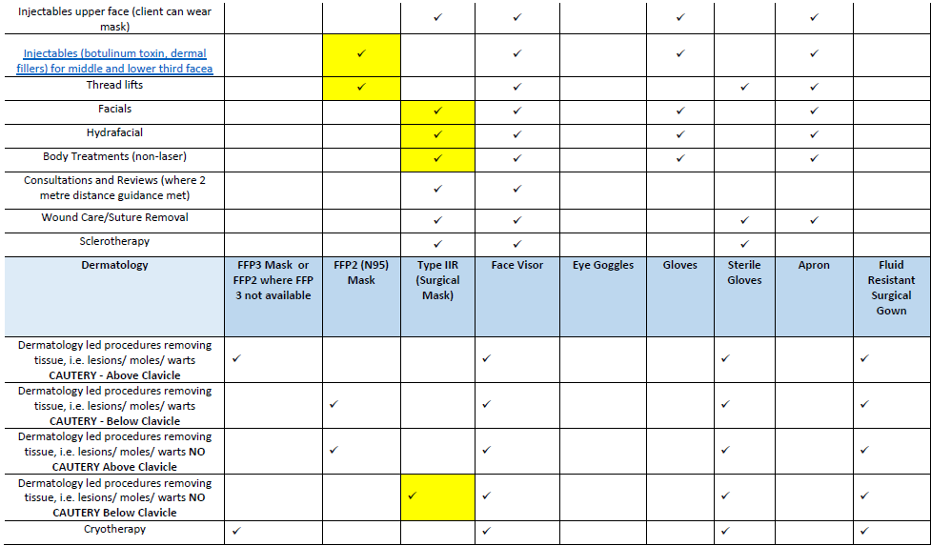

Appendix 2. Covid 19 Risk Consent
Client name:
Date of birth:
Address:

Informed consent – COVID-19 risk

I ______________________________________ (client name) understand and accept the following. I have been given time to consider the information within this document and give my consent to undergo a procedure considering the risks of COVID-19.

- I understand, that I am undergoing an elective procedure through my own choice.
- I understand that COVID-19 is an infectious disease that has been declared a worldwide pandemic by the World Health Organisation and is associated with death in some people.
- I understand there is a risk that I can catch COVID-19 before, during or after the time of the procedure.
- If I suffer from COVID-19 I accept that it can be impossible to determine the contagious source of the disease.
- I understand that even if I have been tested for Coronavirus and received a negative test, the results in some cases fail to detect the virus. I also accept I can contract COVID-19 after a test has been performed.
- I understand that if I fall into the NHS category of Moderate Risk, Clinically Vulnerable, I am more likely to get seriously ill if I contract COVID-19.
- I understand that contracting COVID-19 may result in the following; extended quarantine/self-isolation, additional tests, hospitalisation that may require medical therapy, increased complications for the treatment I am having, and other potential complications associated with COVID-19 treatment.
- I understand that COVID-19 is a new disease and there may be additional risks that are currently unknown and that it is not possible to quantify the risk of complications right now. Case fatality rate for COVID-19 is near 1.4%, this number increases with age.
- I agree that if I develop symptoms, have contact with anyone or have been tested for coronavirus then I will inform the clinic.
- I agree that if I develop COVID-19 and suffer consequences there will be no financial compensation for COVID related complications or consequences.
- I agree that if I develop COVID-19 I will be treated within the NHS in an appropriate setting.
Client Signature: | Sk:n Signature:
Client name: | Sk:n name:
Date: | Date:

Appendix 3. Mask types and uses

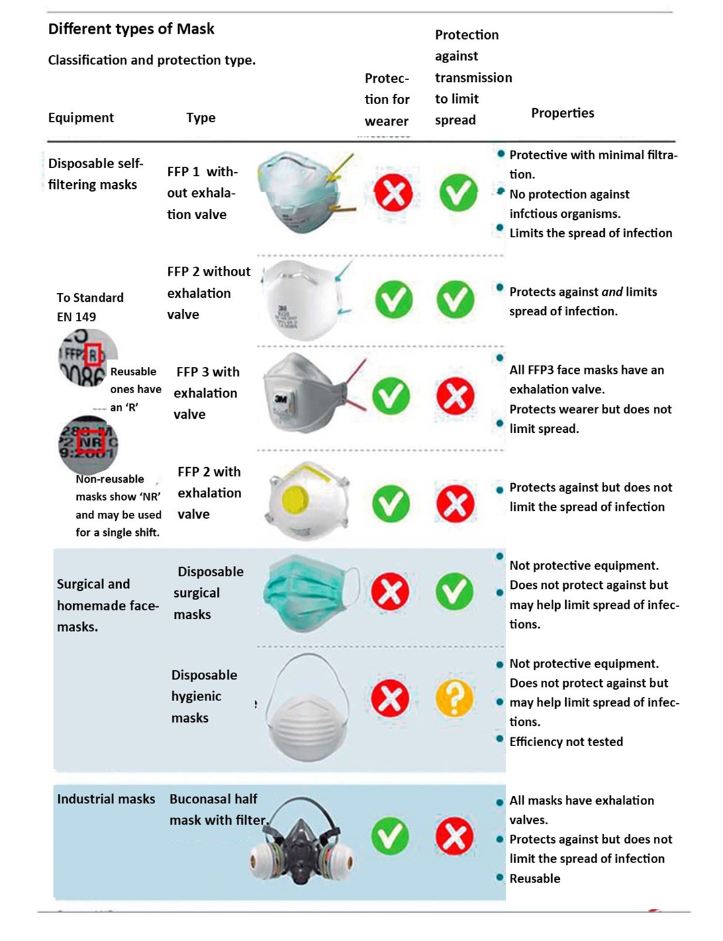

Source: https://jamanetwork.com/journals/jamadermatology/fullarticle/2532614
https://www.hse.gov.uk/news/face-mask-equivalence-aprons-gowns-eye-protection-coronavirus.htm https://www.hse.gov.uk/news/face-mask-equivalence-aprons-gowns-eyeprotectioncoronavirus.htm Guidance on fit testing:
https://www.bmla.co.uk/clinical-guidance-for-laser-procedures-during-the-covid-19-pandemic/
https://www.schuco.co.uk/surgical-smoke-plume/
https://assets.publishing.service.gov.uk/government/uploads/system/uploads/attachment_data/file/87 9498/Guidance-for-businesses-ppe-regulations-version-2.pdf)
https://www.england.nhs.uk/coronavirus/wp-content/uploads/sites/52/2020/04/C0284-ppe-gownsletter-qa-sa.pdf
https://www.ncbi.nlm.nih.gov/pubmed/32035997 https://www.aop.org.uk/coronavirus-updates/coronavirus-how-to-disinfect-optical-equipment-andpremises
https://www.ncbi.nlm.nih.gov/pubmed/32035997

